# Cyclostationarity based detectors:

## ***What is Cyclostationarity?***

* cyclostationary signals have probabilistic parameters that vary periodically with time - mean, variance, higher order moments

## ***Cyclic Autocorrelation function:***

* Represented as a Fourier Series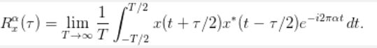
  + where R_x^\alpha(\tau) is a Fourier-series coefficient called the cyclic autocorrelation function. The Fourier frequencies alpha are called cycle frequencies.
  + x(t) is a complex valued signal
* Signal exhibits second order periodicity - CAF is non zero for some non zero alpha
* Reference: <https://cyclostationary.blog/2015/09/28/the-cyclic-autocorrelation/>

## ***Spectral Correlation Density:***

* Fourier transform of CAF



* Estimation: FFT Accumulation method

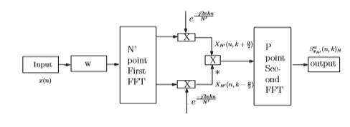

## ***System Model:***

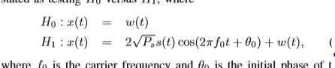

## 

## **Doubts and Clarifications:**

* The distribution of H0 is:



where :



* Why does it depend on Ps when the signal is absent in H0?
* The derivation of distribution of H1